

**II Semester 2024-2025**

**PROJ 3002 Special Project II**

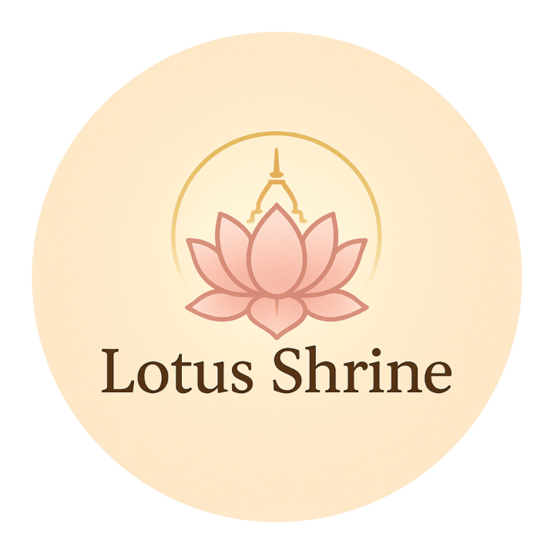

**“Lotus Shrine”**

**Project Outline**

**Table of Contents**

|  |  |  |
| --- | --- | --- |
| No | Contents | Page No. |
| 1 | Basic Project Details | 2 |
| 2 | Introduction | 3 |
| 3 | Abstract | 3 |
| 4 | Objectives | 4 |
| 5 | Project Description | 4 |
| 6 | Knowledge Requirements | 5 |
| 7 | Project Schedule | 6 |
| 8 | Conclusion | 7 |

**Basic Project Details**

Project Title **: Lotus Shrine**

Project Area **: Digital Platform for Buddhist Meditation and Prayer**

**Utilizing Web Development and AI Integration.**

Project Group Name **: Team PeaceTech**

Project Members **:**

1. **Pai Min Thway**

**(2022-MIIT-CSE-002)**

1. **Khant Nyar Thwin**

**(2022-MIIT-CSE-018)**

1. **Myat Mon Mon Zaw**

**(2022-MIIT-CSE-027)**

Instructor-in-charge **: Dr. Myat Thuzar Tun**

Project Supervisor **: Dr. Phyu Myo Thwe**

Offered in **: II Semester 2024-2025**

**(3th July 2025 – October 2025)**

**Introduction**

The **Lotus Shrin**e project is a web application designed to offer **virtual Buddhist meditation and prayer experiences**. Users can visit pagodas virtually, meditate with guided sessions, listen to traditional chants, and access daily Dhamma quotes, making spiritual practices accessible from anywhere.

The platform uses modern web technologies and AI to provide interactive features such as pagoda views and posture detection to improve meditation. Additionally, logged-in users can use the **Koe Na Win Dashboard** to track their prayer history, set meat-free day reminders, and maintain a reflection journal to deepen their practice.

By combining Buddhist traditions with technology, Lotus Shrine aims to promote mindfulness, peace, and cultural connection, especially for those who cannot visit religious sites in person.

**Abstract**

The Lotus Shrine project is a web-based platform that facilitates virtual Buddhist meditation and prayer for users unable to visit physical religious sites. It combines immersive features such as an immersive pagoda viewing experience, guided meditation with AI-powered posture detection, and an audio player for traditional chants. The platform also includes the Koe Na Win Dashboard, allowing users to track their spiritual activities and set personal reminders. By integrating modern web technologies and AI, Lotus Shrine promotes accessibility, mindfulness, and cultural preservation in a digital environment.

**Objectives**

💡Provide a virtual platform for Buddhist meditation and prayer accessible to all users.

💡Create an immersive pagoda viewing experience that feels like a real visit.

💡Implement guided meditation with AI-powered posture detection for user feedback.

💡Develop the Koe Na Win Dashboard for tracking spiritual activities and personal

reminders.

💡Promote mindfulness and spiritual connection through accessible digital technology.

**Project Description**

The Lotus Shrine is a web-based application designed to facilitate virtual Buddhist meditation and prayer experiences. It features immersive pagoda viewing, guided meditation sessions with AI-powered posture detection, and an audio player for traditional chants. The platform also includes a personalized dashboard called Koe Na Win, where users can track their spiritual activities, maintain reflection journals, and set personal reminders.

Built with React.js, JavaScript, HTML, and CSS on the frontend, and PHP with MySQL for backend and data management, the system offers a responsive and interactive environment for users. The application emphasizes privacy and security by ensuring all personal spiritual data is safely stored and only accessible by the logged-in user.

Overall, Lotus Shrine aims to combine traditional Buddhist practices with modern web technology to provide accessible, meaningful spiritual engagement for users regardless of location.

**Knowledge Requirements**

• **Front-End Development:**

* Proficiency in HTML, CSS, JavaScript, and React.js for creating an interactive and user-friendly interface.
* Familiarity with responsive design principles to ensure compatibility across devices and browsers.

• **Back-End Development:**

* Experience with PHP for server-side programming, API development, and session management.
* Knowledge of integrating AI-powered features, such as posture detection using Google Teachable Machine.
* Ability to connect front-end components with backend services seamlessly.

• **Database Management:**

* Proficiency in MySQL for designing and managing database schemas, and performing CRUD operations.
* Experience in securely storing and retrieving user data related to prayers, meditation logs, and reminders.

• **UI/UX Design:**

* Familiarity with design tools like Figma to prototype and design intuitive and culturally respectful user interfaces.
* Skills in creating immersive and calming user experiences suitable for meditation and prayer.

• **System Integration & Security:**

* Understanding how to integrate front-end, back-end, AI modules, and databases into a cohesive system.
* Awareness of data privacy and security best practices to protect sensitive user information and permissions.

• **Project-Specific Knowledge:**

* Understanding of Buddhist meditation and prayer practices, including virtual pagoda experiences and AI-assisted posture detection.
* Familiarity with the Koe Na Win Dashboard for tracking personal prayer history, reflection journals, and spiritual reminders.

**Project Schedule**

|  |  |
| --- | --- |
| **Weeks 1-2** | **Initiate** the project by organizing the team and collecting detailed requirements. **Define** and **finalize** the project goals, deliverables, and overall system specifications. |
| **Weeks 3-4** | **Create** the system’s architecture and **design** the database structure. Begin **UI/UX design** using **Figma** by developing **wireframes** and interactive **prototypes**. Start **front-end** development using **React.js** along with **HTML, CSS, and JavaScript** |
| **Weeks 5-6** | **Enhance** the UI/UX designs and commence **back-end** development with **PHP**. Establish the **MySQL** database and **implement** **connections** between front-end and back-end components. |
| **Week 7** | |  | | --- | | **Integrate** AI-driven posture detection using **Google** **Teachable** **Machine** and test its functionality within the meditation feature. |  |  | | --- | |  | |
| **Week 8** | |  | | --- | | **Prepare** and deliver the **Mid-Semester Seminar** and report. **Showcase** the project progress, including UI/UX prototypes and AI integration demos. |  |  | | --- | |  | |
| **Weeks 9-11** | |  | | --- | | **Apply** feedback from the seminar to **improve** UI elements and AI features. **Conduct** thorough debugging and optimize system performance. |  |  | | --- | |  | |
| **Weeks 12-14** | |  | | --- | | Perform comprehensive system testing with real data and user acceptance testing (**UAT**). Refine the application interface and features based on test results. |  |  | | --- | |  | |
| **Weeks 15-16** | |  | | --- | | **Complete** **final** **documentation** and reporting. **Prepare** **presentation** materials and perform last rounds of testing and UI/UX improvements. |  |  | | --- | |  | |
| **Week 17** | **Submit** the final report and **conduct** the **final** **seminar** presentation, demonstrating the **fully functional Lotus Shrine web application**. |

**Conclusion**

The **Lotus Shrine** web application successfully combines **modern technology** with **ancient Buddhist practices** to create a **peaceful and accessible spiritual experience** for users worldwide. By offering features such as **immersive pagoda viewing**, **AI-powered meditation posture detection**, and the personalized **Koe Na Win Dashboard**, the app supports users in their meditation and prayer routines, regardless of their physical location.

This project demonstrates the effective use of **React.js, PHP, MySQL**, and **AI integration** to build a responsive and user-friendly platform. It prioritizes **user privacy and data security**, ensuring that all personal spiritual activities are handled with respect and confidentiality.

Overall, **Lotus Shrine** not only fosters mindfulness and devotion but also bridges the gap between tradition and technology, providing a meaningful way for individuals to stay connected with their faith in the digital age.